Title: The Expansion of Top Level Domains

Written by: Andrew Beveridge [H00013703]
Course: Praxis [F27PX]

Introduction
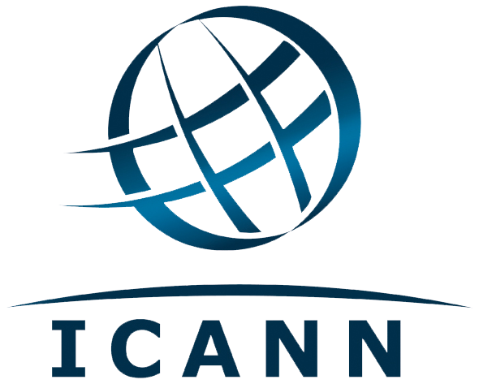
The Internet naming board ICANN (Internet Corporation for Assigned Names and Numbers) made the decision to allow the number of top-level domains to increase at a special board meeting on the 20th June 2011.
“Today’s decision will usher in a new internet age. We have provided a platform for the next generation of creativity and inspiration. Unless there is a good reason to restrain it, innovation should be allowed to run free.” said Peter Dengate Thrush, chairman of ICANN’s board of directors. (Arthur, 2011 [online])
The new generic top-level domains (gTLDs) will change the way people plan and structure their online presence. Internet address names will be able to end with almost any word in any language, offering organisations around the world the opportunity to market their brand, products, community or cause in new and innovative ways.
Currently there are only 22 gTLDs, which includes such familiar domains as .com, .org and .net.

Reasons for change

Benefits

“ICANN has opened the Internet’s naming system to unleash the global human imagination. Today’s decision respects the rights of groups to create new Top Level Domains in any language or script. We hope this allows the domain name system to better serve all of mankind” said Rod Beckstrom, President and Chief Executive Officer of ICANN. (ICANN, 2011 [online])
Increased flexibility and creativity which will be allowed by the new system is the key point stressed by ICANN, as websites will no longer be restricted to the archaic “.com” or country-specific TLDs. Businesses who can afford to purchase and maintain a gTLD will have unlimited options for creative addressing, as they will have complete control over all second-level domains beneath the gTLD. For example, Adidas AG could register “.adidas”, then easily and freely create “running.adidas”, “football.adidas”, “tennis.adidas” and so on, without any restrictions or extra costs involved, or other parties to compete with over product-related domains, since all would be beneath the restricted “.adidas” umbrella.
Also, as gTLDs will be allowed in any language or script, the scope for non-english speaking countries creating more natural domain names will become a reality. ICANN have been working towards internationalizing the domain name system for years, but it is a complicated task with many technical challenges to overcome, and it seems that with the introduction of customised gTLDs in any language, they have finally opened up the internet to other languages.
Security is also important, and this development in the naming system is set to increase security for organisations with multiple online assets. Registering a gTLD specific to the organisation or business will create a trusted space, where second-level domain names can only be registered by, for example, a company’s partners and authorised agents. By utilising this technique, the company and its customers will know that the space is secure and that the products or services sold in the space are authentic.

Problems with existing system

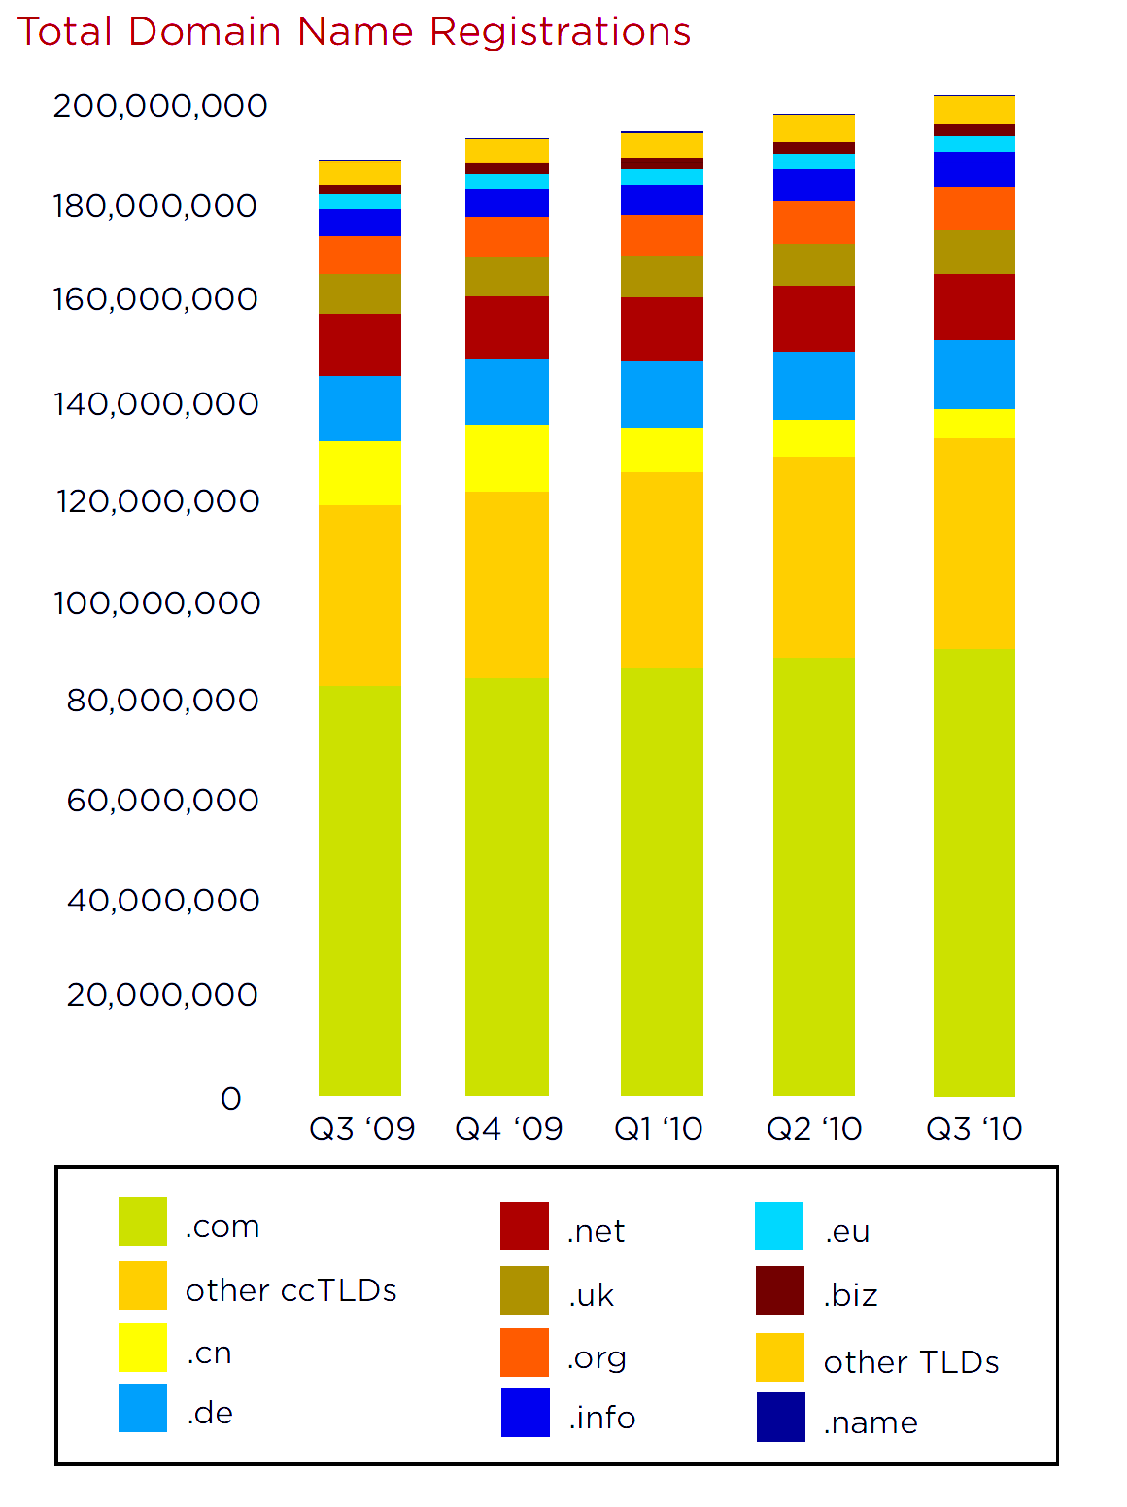
“.com” was created 26 years ago (Arthur, 2011 [online]). Since then, over 21 million domains have been registered using the “.com” suffix alone (Domain Worldwide, 2011 [online]). Because of this huge number of existing domain names, there are very few short names left, and a large business desiring a domain name for a new brand may find a smaller business or personal user has already registered the name, and end up having to make a decision between paying a very large sum of money to the existing owner for the name, or give up on it and choose an similar address, or even change the brand name. The original TLDs were designed with diversity in mind - back in 1985 it seemed that “.com”, “.edu”, “.gov”, “.mil”, and “.org” would be the only TLDs anyone would need. Since then, the Internet has expanded enormously, and it has become apparent that it is used by far more groups than “companies”, “educational”, “government”, “military” and “organisations”. There have been a few more TLDs created since then, such as .asia, .cat, .jobs, .mobi, .tel, .travel, .aero, .coop, .museum, .biz, .info, .name, and .pro, some of which have use restrictions in place to ensure they retain some meaning (unlike .com, which can be used for any purpose). However, the few TLDs which exist only cover one or two sectors of website. There have been several cases where one of the country-specific TLDs is rarely used for domains relating to the country it was intended for, because it happens to be an acronym for something more common. One example is the country-specific TLD for the tiny pacific island of Tuvalu, “.tv”. The country has a population of less than 11,000, yet there are now over 473,000 domains registered using the “.tv” suffix.
(Zooknic, 2011 [online])
Obviously, this is because of the entertainment and media industry capitalising on the TLD for television-related websites, rather than using “.com”, as “.tv” is shorter and more relevant. While this practice has been very good for the economy of Tuvalu (Kaplan, 2000 [online]), it goes to show that there is a strong desire for more relevant TLDs, and while “dot com” may be firmly embedded in the mind, there are obvious benefits in segregating the online naming system.

Costs

Applying for a new gTLD will cost an unappetizing $185,000, and once a gTLD is secured, a minimum of $25,000 a year fee for ICANN’s services must be paid. These are just the starting costs, however. In reality costs will be much higher, with fees for string contention (competitors looking to register similar domains), application advocacy, and substantial legal fees surrounding intellectual property and trademark laws. Running a gTLD will also require internal staff to administer registrations, ensure policy compliance, maintain registry infrastructure, audit activities, etc. In the end, some estimate that to simply apply for a branded gTLD the figure will most likely approach $400,000, with another $150,000 or more annually to operate it. Some large corporations have already admitted to budgeting nearly $1million just to acquire and launch a gTLD (MarkMonitor, 2011 [online]).
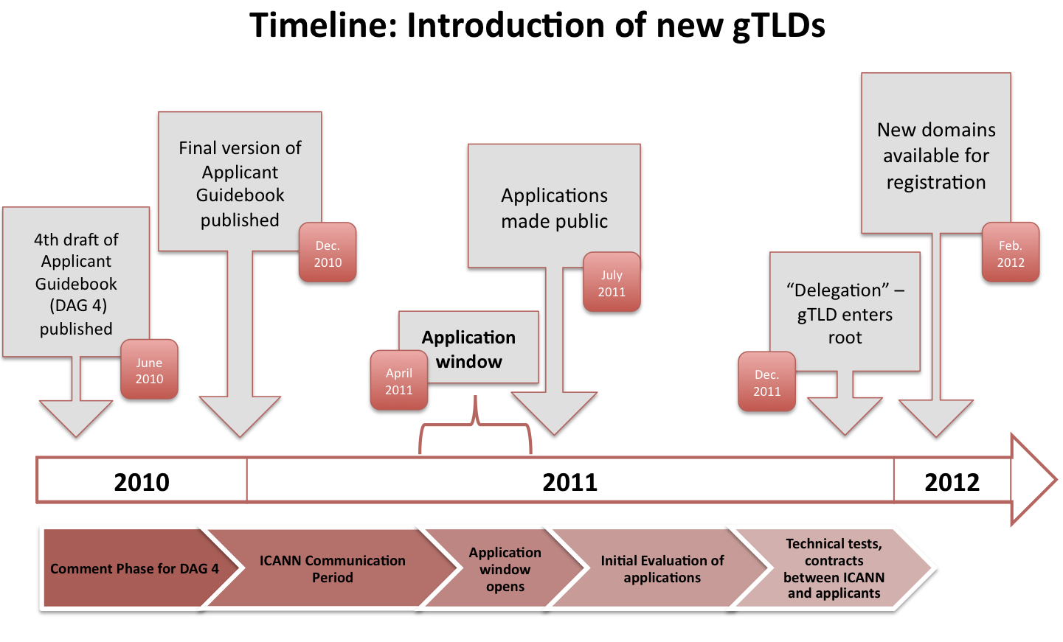
Timeline: Introduction of new gTLDs
(Couvering, 2010 [online])

Administration

On top of the high startup and maintenance costs, ICANN are forcing any gTLD owner to satisfy lots of requirements, to ensure the system is not abused. The operator of the registry is locked into a 10 year contract, during which they must (Rosaya, 2011 [online]):
- Operate the gTLD in a stable and secure manner.
- Comply with consensus policies and temporary policies of ICANN.
- Implement start-up rights protection measures such as a sunrise period and trade mark claims services
- Implement post-launch rights protection measures
- Implement measures for protection of country and territory names in the new gTLD.
- Pay recurring fees to ICANN.
- Deposit data into escrow regularly.
- Deliver monthly reports to ICANN.
- Provide a “Who is” service for domain names registered in the top-level domain (TLD).
- Maintain partnerships with ICANN-accredited registrars.
- Maintain an abuse point of contact.
- Co-operate with contractual compliance audits.
- Maintain a continued operations instrument.
- Maintain community-based policies and procedures.
- Have continuity and transition plans in place.
- Make TLD zone files available via a standardised process.
- Implement domain name system security extensions.
These considerable administration requirements will go a long way to ensuring the only organisations running gTLDs are fit and able to, and trustworthy members of the online community, as long as ICANN ensure they are all met satisfactorily.

Risks

Phishing

Phishing is the activity where a fraudulent company registers domain names which look similar to a legitimate company, then trick users into entering their personal details, under the guise of the trusted website. The expansion of TLDs to include languages and scripts other than english increases the opportunities for trickery greatly, as non-english characters can look similar to english characters, causing possible confusion. The potential for registering TLDs using characters which were previously unavailable for use be very attractive to fraudsters aiming to set up phishing sites, since one successfully-registered TLD using characters to make it look like a legitimate brand could allow for limitless second-level domains beneath it, all with their own fraudulent purpose using the guise of the imitated brand. As an example, somebody could register the TLD “göögle”, where the letter o from the google brand is replaced by o with umlaut. They could then set up domains such as “search.göögle” and set up a page at that address to look identical to Google’s official site, tricking people into using the page instead of Google, potentially installing malware on visitors’ computers when accessing the site. The only way to ensure this does not happen is for ICANN to check every TLD application meticulously, to ensure it has a legitimate purpose, a registered organisation behind it and is not imitating any other brand.

Cybersquatting

Cybersquatting is an umbrella term for the practice of registering domain names for a purpose other than creating an active website. A company might register domains similar to the primary name used by a competitor, to catch users who make typographical errors when entering the domain, or to spread misinformation about the company by creating a webpage masquerading as the company. Another practice covered by the cybersquatting term is buying large quantities of domains with keywords or names in them, waiting for a someone to decide they want that domain name, then selling the domain to the business or individual at an inflated price. These activities are deemed similar to “squatting”, the act of occupying an abandoned or unoccupied space or building. “Some squatters make it a business to register the names of famous people and businesses who have yet to register their domain names. The squatters register these names and then attempt to negotiate with the famous person or business to release the name.” (Givens, 2010 [online])
ICANN’s latest change to the domain name system will expand the opportunities for cybersquatters dramatically, as there will soon be hundreds of TLDs controlled by different companies, each with the potential to be used as a cybersquat for a brand name. For example, someone could register the gTLD “.rice” and monetize uncle.rice and ben.rice in order to steal traffic from the trademark Uncle Ben when people search for uncle ben rice.
“It [the gTLD expansion] just means that organisations will have around 500 places to defend their brand name in the next few years,” said Charlie Abrahams, vice president of Europe for brand protection firm MarkMonitor. (Marshall, 2011 [online])

Conclusion

Technology is endlessly evolving: ideas conceived over two decades ago usually have little relevance in today’s world. The Internet is no exception - so many people have a web presence now, the top-level domains which we have lived with for so long are no longer fit for purpose. Whether it is good for business or not, ICANN are changing the game in a big way, and only time will tell how it will affect the Internet as we know it.

References

Arthur, Charles. 2011. Internet domain addresses opened up to wave of new suffixes. [ONLINE] Available at: http://www.guardian.co.uk/technology/2011/jun/20/internet-domain-wave-new-suffixes.
[Accessed 28 July 11].

BBC. 2011. Icann increases web domain suffixes. [ONLINE] Available at: http://www.bbc.co.uk/news/technology-13835997. [Accessed 28 July 11].

Domain Worldwide. 2011. The Daily Domain Counts of Domains Worldwide.. [ONLINE] Available at: http://domainworldwide.com/. [Accessed 28 July 11].

Givens, Latoicha. 2010. How To Combat Cybersquatting. [ONLINE] Available at: http://www.blackweb20.com/2010/05/04/how-to-combat-cybersquatting/.
[Accessed 28 July 11].

ICANN. 2011. ICANN Approves Historic Change to Internet’s Domain Name System. [ONLINE] Available at: http://www.icann.org/en/news/releases/release-20jun11-en.pdf. [Accessed 28 July 11].

Kaplan, Karen. 2000. Pacific Island Hits Internet Letters Jackpot . [ONLINE] Available at: http://articles.latimes.com/2000/apr/07/news/mn-16903. [Accessed 28 July 11].

MarkMonitor, Inc. 2011. Evaluating New Top-Level Domains: Opportunity or Threat?. [ONLINE] Available at: https://www.markmonitor.com/download/wp/wp-gTLD.pdf. [Accessed 28 July 11].

Marshall, Rosalie. 2011. New gTLDs spark cyber squatting concerns. [ONLINE] Available at: http://www.v3.co.uk/v3-uk/news/2080204/gtlds-spark-cyber-squatting-concerns. [Accessed 28 July 11].

Rosaya, Lisa W. . 2011. Domain names: the new era of expansion is here! . [ONLINE] Available at: http://uscorporate.practicallaw.com/6-506-5899. [Accessed 28 July 11].

Bibliography

Al-Zoman, Abdulaziz. 2003. Arabic Top-Level Domain Names. [ONLINE] Available at: http://arabic-domains.org/docs/NIC-docs/IJCPOL-ArabicTLDs-Final.pdf. [Accessed 28 July 11].

Berkens, Michael . 2009. Thinking About Applying For Your Own gTLD? It Could Cost You A Lot More Than $185K . [ONLINE] Available at: http://www.thedomains.com/2009/02/21/thinking-about-applying-for-your-own-gtld-it-could-cost-you-a-lot-more-than-185k/. [Accessed 28 July 11].

Zooknic. 2011. Domain Name Counts. [ONLINE] Available at: http://www.zooknic.com/Domains/counts.html. [Accessed 28 July 2011].

